***E-grocery***

**Project Name**

E-Grocery Website

**Documentation Title**

Frontend Development Documentation

**Description:  
*“A user-friendly e-grocery website allowing easy navigation through categories and a seamless order placement experience.”***

**Prepared By**

SDGI Online Interns

**Version**

1.0

**Technologies Used**

HTML,CSS,Javascript.

**Github Repository**

[https://github.com/2003kalpna/E-Grocery2.git](https://github.com/2003kalpna/E-Grocery2.git%20)

**Project Overview**

The E-Grocery Website is designed to offer a simple and efficient way for users to shop for groceries online. The website is entirely frontend-based and built using HTML, CSS, and JavaScript. The site consists of multiple pages that allow users to browse various product categories, access information about the store, and place orders.

**Key Features**:

1. **Home Page**:  
   A landing page that provides an overview of the website, showcasing categories of grocery items.
2. **About Us Page**:  
   This page contains information about the store, its mission, and values.
3. **Contact Us Page**:  
   A page where users can find contact information and submit inquiries via a form.
4. **Shop Pages**:  
   Four different shop pages are categorized to help users easily navigate and find products. These categories include:
   * **Cleaning Items**
   * **Kitchen Utensils**
   * **Packed Food Items**
   * **Food Grains**
5. **User Login and Sign-Up Page**:  
   This feature allows new users to create an account via the sign-up page. Registered users can log in to their accounts to manage orders.
6. **Order Page**:  
   After selecting products, the user can proceed to the order page to fill out their basic details, such as name, shipping address, and payment method.
7. **Thank You Page**:  
   After submitting the order, the user is directed to a thank you page that confirms the order has been placed successfully.

**Technologies Used**

* **HTML**:  
  Used for creating the structure of the web pages, such as forms, buttons, navigation bars, and content sections.
* **CSS**:  
  Applied for styling the website to make it visually appealing, including the use of layout techniques (e.g., Flexbox, Grid).
* **JavaScript**:  
  Incorporated to add interactivity to the website, such as form validation, page navigation, and dynamic content updates.
* **Figma**:  
  Used for designing the UI prototype and wireframes, providing a visual blueprint of the entire project before implementation.
* **Microsoft Word**:  
  Used to create flowcharts and the ER diagram, planning the structure and flow of the website.

**Design Process**

1. **Wireframes and Flowcharts**:

* Created wireframes for all the key pages of the website (Home, Shop, Login, Order).
* Designed the user flow using **Figma** and **Word**, which visualized the process from landing on the website to placing an order or logging in.
* The flowchart helped ensure a seamless user experience, allowing for easy navigation between product categories and the order process.

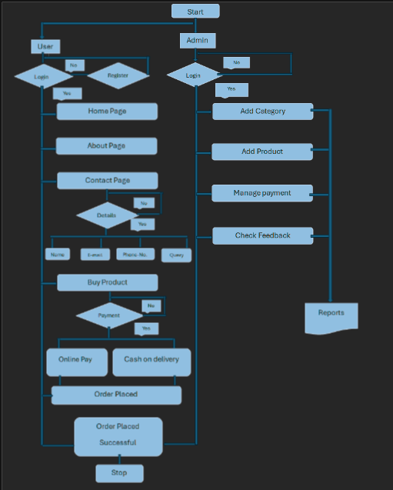

**2. E-Diagram**:

* Developed the ER Diagram using **Word** to define the structure of how user accounts, orders, and products might be managed in a real-world scenario. This is particularly important for understanding how a backend could integrate in future iterations.

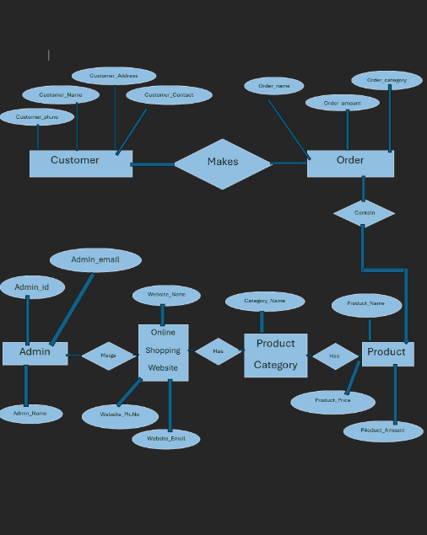

**Code Structure**

**1. HTML Files:**

* Each major page (Home, About, Shop, Login, Order) has its own HTML file**.**
* Consistent use of semantic HTML tags for better structure and accessibility.

**2. CSS Styles:**

* Separate css files are maintain for each html file for better readability or to avoid conflicts in styling.

**3. JavaScript:**

* All user interactions, including form validation, navigation, and dynamic elements (like order confirmation), are handled using JavaScript.
* JavaScript files are modular, with functions clearly separated for better readability and maintenance.

**Code Screenshots**

**HTML**:Home Page Structure

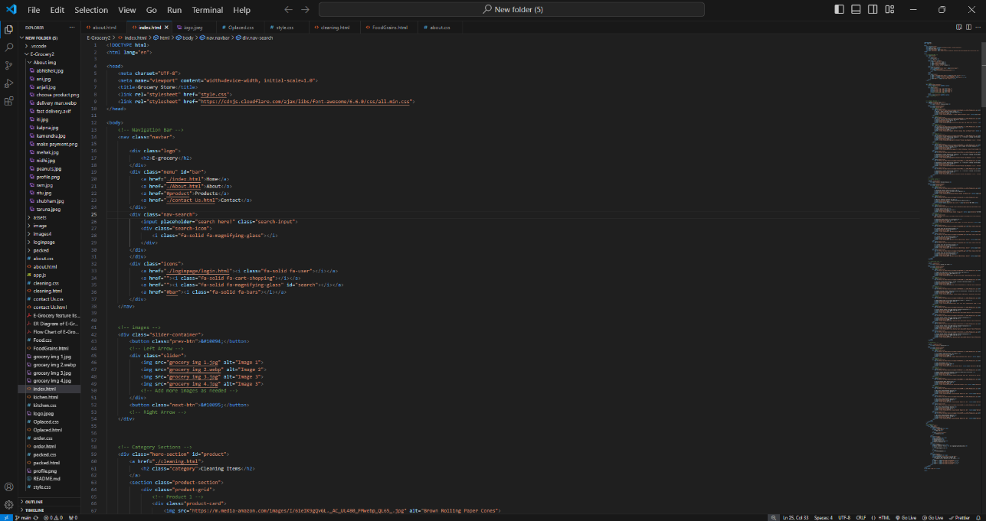

**CSS**:Responsive design using media queries

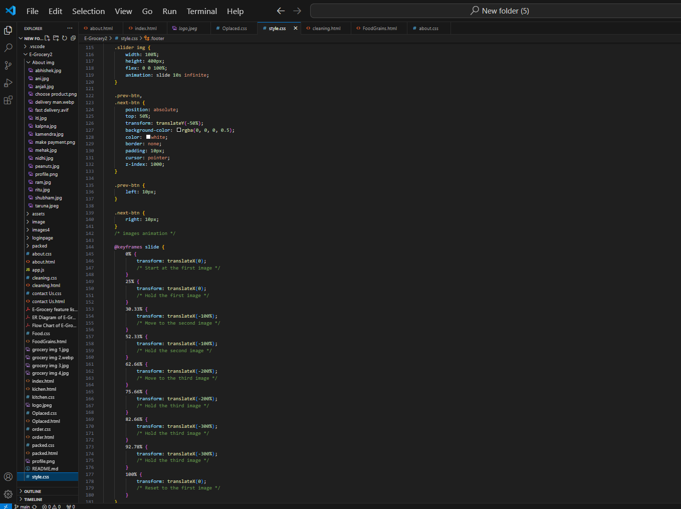

**Javascript**:Form Validation

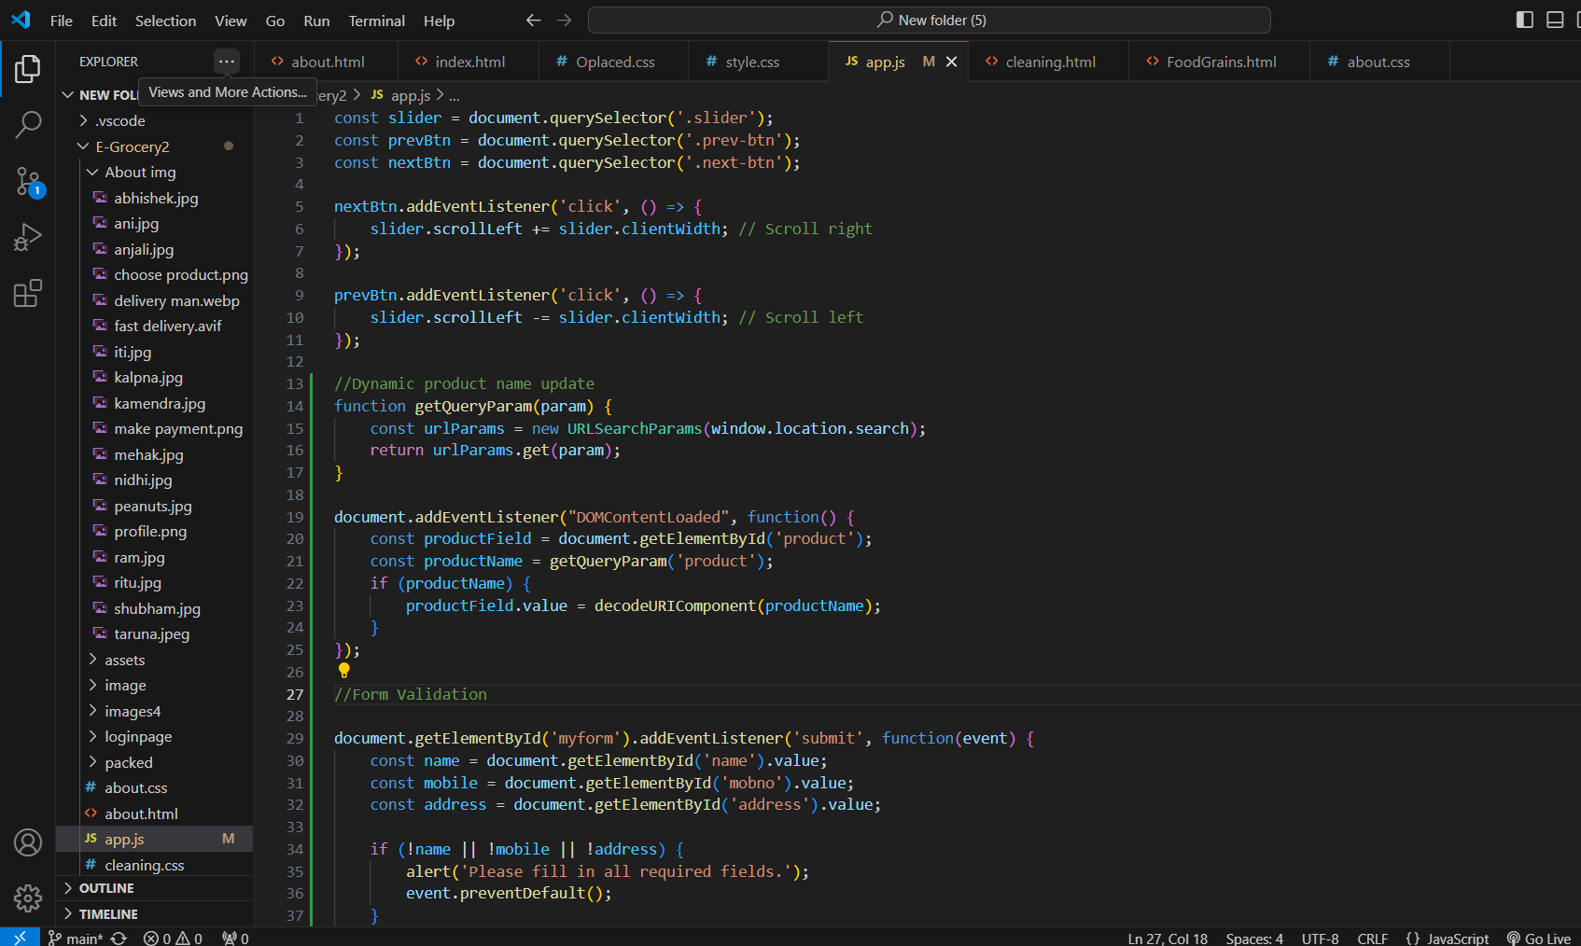

**User Flow:**

1. **Landing on the Home Page**

* Users arrive at the homepage, where they are greeted with categories of products.
* The navigation bar allows users to visit **About Us**, **Contact Us**, and **Shop Pages**.

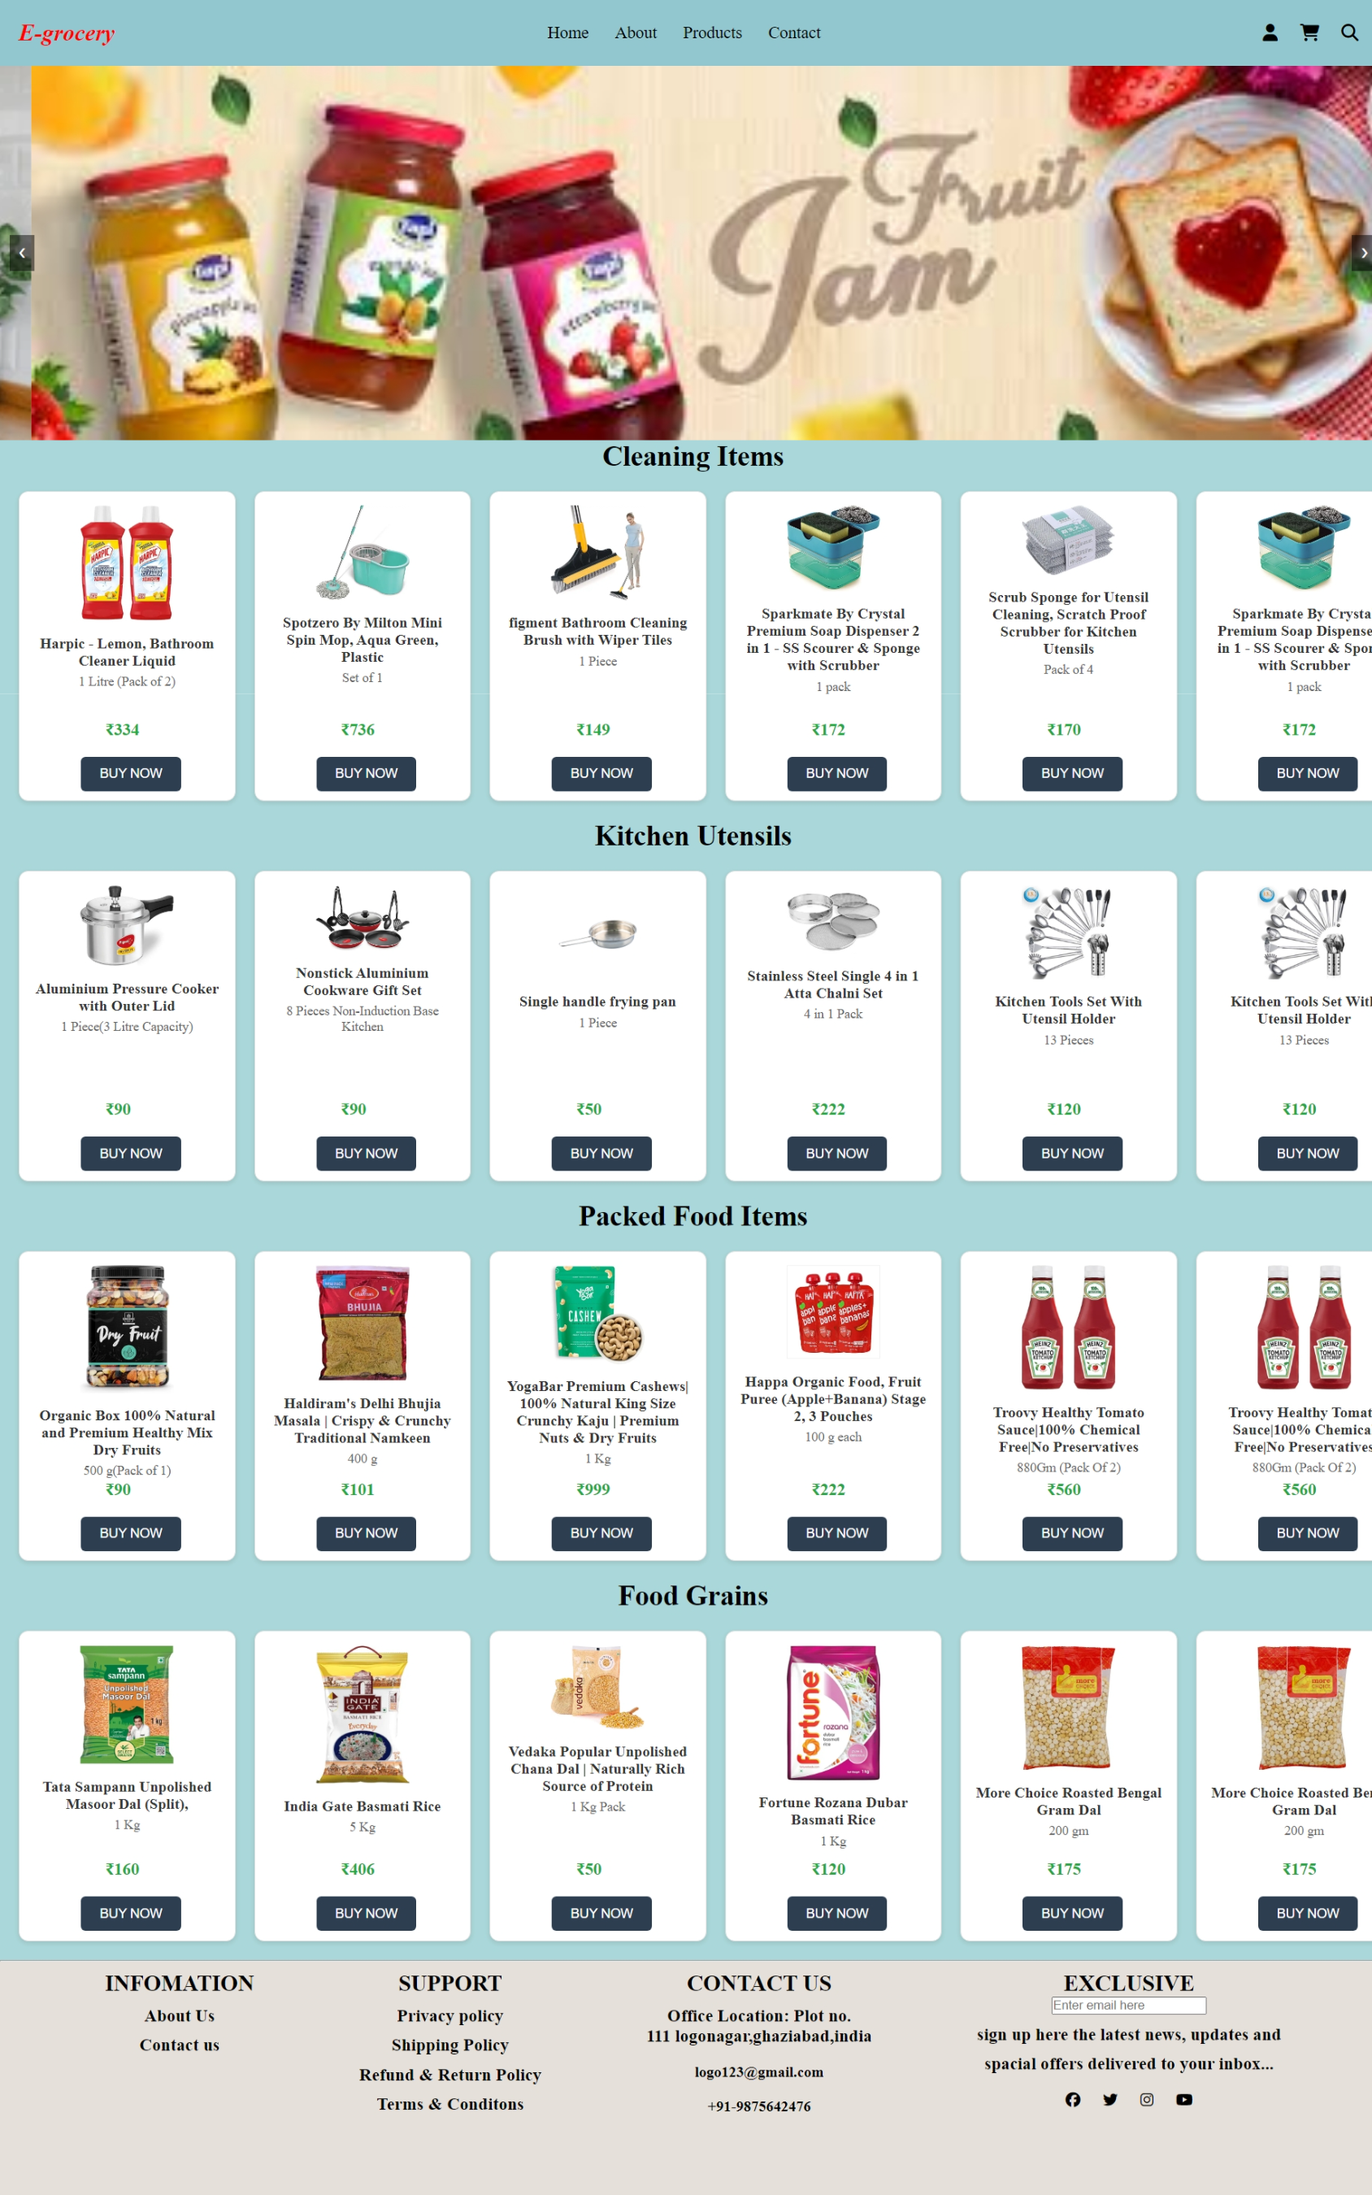

**2. Browsing Products (Shop Pages)**

* From the homepage or navigation menu, users can select a product category (e.g., cleaning items, packed food, kitchen utensils, food grains).
* Users are directed to the respective shop page where they can browse items.

Category2:Kitchen Utensils

Category1:Cleaning Items

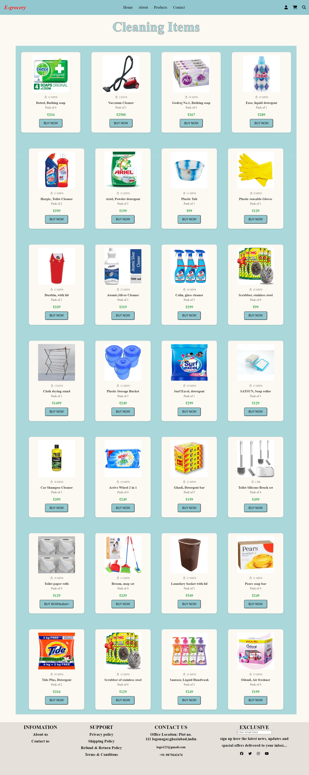 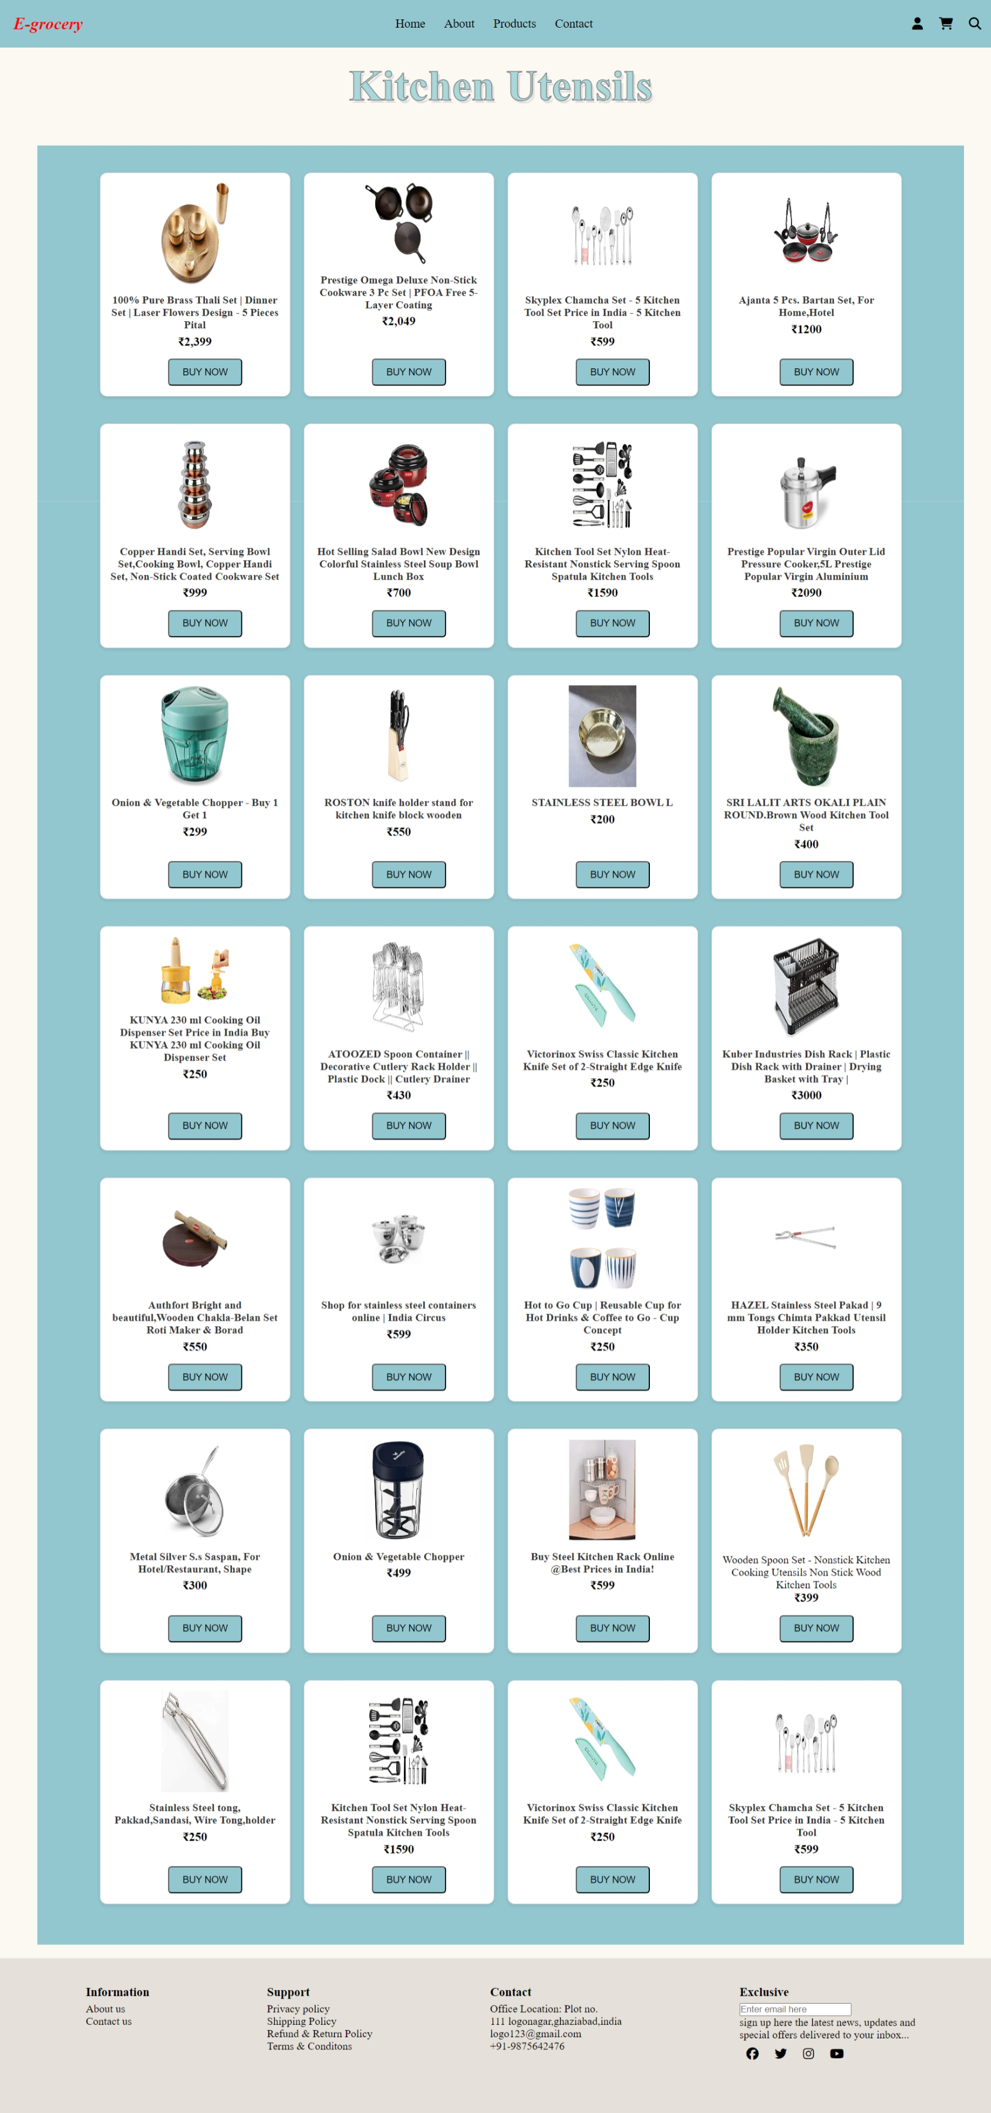

Category4:Food Grains

Category3:Packed Food Items

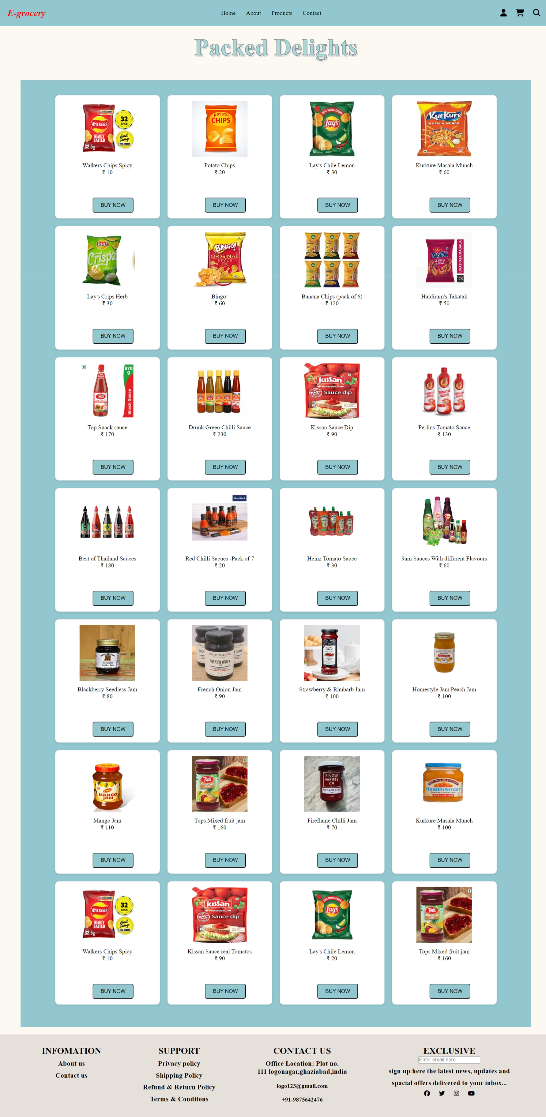 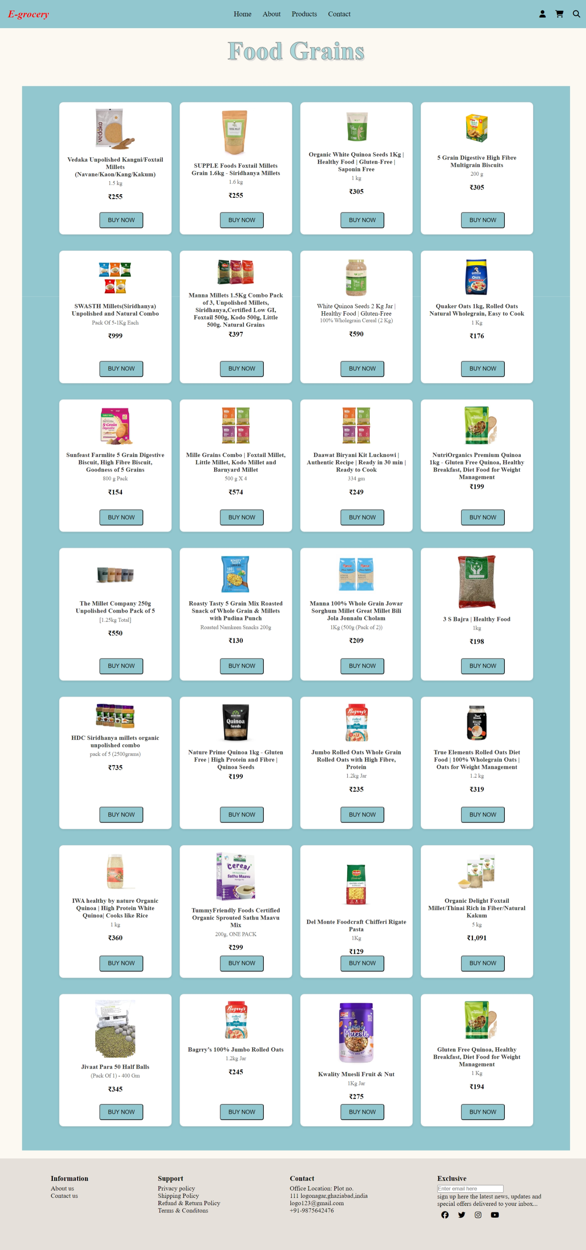

**3. Buy Products**

* On each shop page, users can view product details and click the "Buy Now" button for items they want to purchase.
* Clicking "Buy Now" takes the user to the **Order Page**.

**4. Placing an Order**

* On the **Order Page**, users fill in their personal details (name, address, etc.) and select the product quantity.
* After filling in the details, users submit the form to place the order.
* A **Thank You** message is displayed upon successful submission.

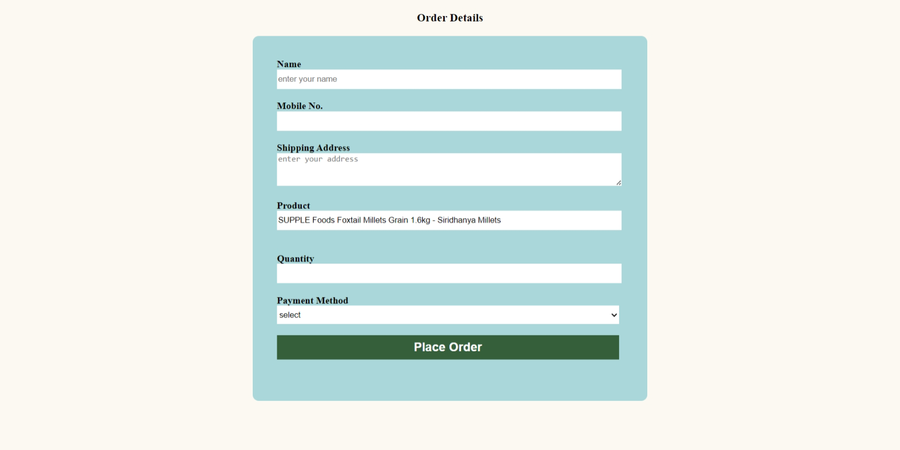

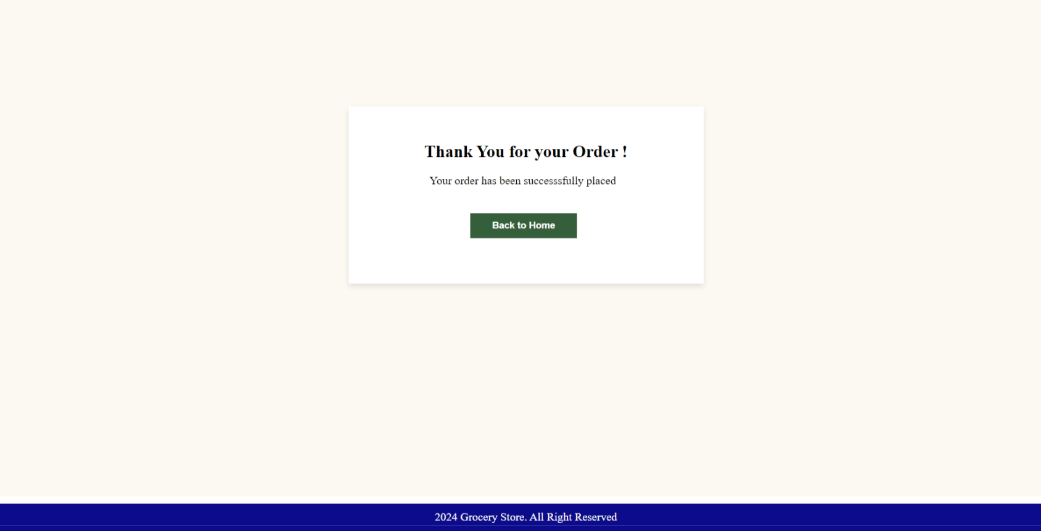

**Testing and Debugging**

For this project, manual testing was carried out to ensure the website functioned as intended across all pages. The following aspects were tested:

**1. Page Navigation Testing**

* **Objective**: Ensure that all links and buttons direct users to the correct pages.
* **Manual Test**: Tested navigation from the homepage to the various shop pages, order page, and login/sign-up pages. Also verified that clicking the "Buy Now" button properly redirected users to the order form.
* **Result**: All page transitions worked smoothly.

**2. Form Validation Testing**

* **Objective**: Verify that the forms (Login, Sign-up, and Order forms) worked correctly and prompted for input errors.
* **Manual Test**: Filled out forms with valid and invalid data to ensure that appropriate validation messages were shown when fields were missing or improperly formatted (e.g., email).
* **Result**: Validation worked as expected. Error messages were displayed when incorrect inputs were entered.

**Debugging Process**

During the development of the e-grocery website, several issues arose that required debugging to ensure smooth functionality. The following steps were taken to troubleshoot and resolve these issues:

**1. Browser Developer Tools**  
Used developer tools in Google Chrome (Chrome DevTools) and other browsers to inspect HTML elements, check for JavaScript errors, and adjust CSS properties directly in the browser.

* **Issue**: Some CSS styles weren't rendering correctly.
* **Solution**: Used the "Inspect Element" feature to test and apply new CSS rules dynamically until the layout displayed properly. Then, updated the relevant CSS file with the working styles.

**2. Form Validation Errors**  
Encountered issues with JavaScript-based form validation where some fields weren't being checked correctly.

* **Issue:** The quantity field was accepting negative values, which led to incorrect inputs for product orders.
* **Solution:** Set a minimum value of 1 for the quantity field using the min attribute in HTML. This ensures that users can only enter positive values.

**3. JavaScript Event Handling**  
Faced challenges with certain buttons not triggering the correct JavaScript functions, particularly on the **Order Page**.

* **Issue**: The "Place Order" button wasn’t responding when clicked.
* **Solution**: Checked the event listeners using browser dev tools and realized that the JavaScript function wasn’t properly linked to the button. Reattached the event listener and ensured that the form submission worked properly.

**Conclusion:**

The e-grocery website project was an excellent opportunity to deepen our knowledge of frontend development. By implementing multiple pages and ensuring smooth navigation, we was able to create a user-friendly interface. This project helped us strengthen our skills in HTML, CSS, and JavaScript, and gain experience in handling user interaction and form validation. Overall, the website successfully meets the design and functional goals set at the beginning of the project.

**Future Enhancements:**

* **Backend Integration**: Implementing a backend to store and manage user accounts, orders, and product data.
* **Payment Gateway**: Adding an integrated payment system for users to complete their transactions online.
* **Product Reviews**: Allowing users to review and rate products.
* **Wishlist Feature**: Adding a wishlist functionality so users can save items for future purchases.
* **Search Functionality**: Implementing a search bar to allow users to quickly find products.

**Final Remarks**

The development of the e-grocery website provided a valuable learning experience in building a functional frontend interface. The project successfully meets the requirements of a user-friendly platform where users can browse, order, and manage products. Throughout the project, our team gained insights into HTML, CSS, and JavaScript, as well as practical experience with design tools like Figma.

This project has laid a strong foundation for further development, where additional features and a backend can be incorporated to enhance the website's capabilities.

**Github Repository:** [https://github.com/2003kalpna/E-Grocery2.git](https://github.com/2003kalpna/E-Grocery2.git%20)